Technical Analysis
- Discipline that analyzes statistical trends from trading activity to evaluate and identify trading opportunities.
- Assumptions
  - The market discounts everything
  - Price movies in trends
  - History tends to repeat itself

Technical Indicators
- Technical indicators are mathematical calculations based on the price, volume, or open interest of a security or contract
  - Commonly used for short-term trades, however, can be utilized for longer term positions
- Display Types
  - Overlays: Displayed over the main price chart of asset
  - Oscillators/Indicators: Exist as separate charts below the main price chart
- Categories
- Trend Indicators: Measure direction/strength by comparing prices to set baseline
- Momentum Indicators: Compares current closing prices with previous closes, identifies speed of price movement
- Volatility Indicators: Measures rate of price movement in either direction
- Volume Indicators: Measures strength of trend based on volume traded

Candlestick Terminology
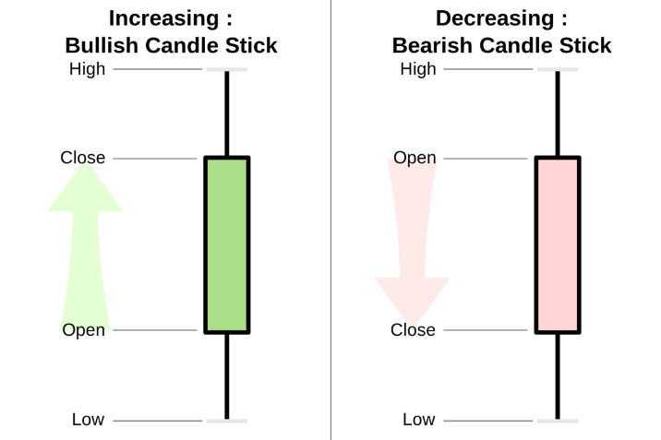
- Components of a candlestick
  - Upper Shadow
  - Real Body
  - Lower Shadow
- Bull/Bear Candlesticks
- Doji Candlestick
  - Little to no price action in real body
  - Could signify ending of a trend, or skepticism of uptrend/downtrend

Moving Averages
- Mathematical average calculated from a certain amount of past data points
- Two Types
  - Simple Moving Average (SMA)
  - Exponential Moving Average (EMA): Increased weight on more recent data
- Strategies
  - Crossover of Asset
  - Crossover of Two Moving Averages
    - Bullish Crossover
    - Bearish Crossover
- Disadvantages
  - Lagging Indicator
  - Shaky Success in Volatile Industries
  - “Market has no Memory” Ideology

Candlestick Patterns
- Head and Shoulders
  - Possible significance of trend reversal
  - HS-Top/HS-Bottom
- Double Top/Bottom
  - Reversal Pattern
  - Prices potentially lost their rally

Trendlines
- Used to identify uptrends/downtrends
- The more points of confirmation, more validity of trendline
- Types
  - Support Lines
  - Resistance Lines
  - Channels

Moving Average Convergence/Divergence (MACD)
- Portrays relationship between two moving averages
- Three Components
  - MACD Line
  - Signal Line
  - Baseline
- Strategies
  - Crossovers
  - Divergences
  - Rapid Movements

